1. Bukalah tugas ([📄12. Soal Assets, Dialog Bottomsheet, Navigation](https://cobalt-bike-c9e.notion.site/12-Soal-Assets-Dialog-Bottomsheet-Navigation-b0ce043cec734de0adb835ee185c9850) )
2. Tambahkan fitur login dengan input username dan password kemudian simpan pada shared preferences. tampilkan username pada halaman Contacts.

* LoginScreen.dart

import 'package:flutter/material.dart';

import 'package:shared_preferences/shared_preferences.dart';

class LoginScreen extends StatefulWidget {

const LoginScreen({Key? key}) : super(key: key);

@override

State<LoginScreen> createState() => _LoginScreenState();

}

class _LoginScreenState extends State<LoginScreen> {

final TextEditingController usernameController = TextEditingController();

final TextEditingController passwordController = TextEditingController();

final _formKey = GlobalKey<FormState>();

bool _secureText = true;

bool isLoading = false;

final ButtonStyle raisedButtonStyle = ElevatedButton.styleFrom(

onPrimary: Colors.white,

primary: const Color.fromARGB(255, 62, 191, 57),

minimumSize: const Size(88, 36),

padding: const EdgeInsets.symmetric(vertical: 18),

shape: const RoundedRectangleBorder(

borderRadius: BorderRadius.all(Radius.circular(20)),

));

showHide() {

setState(() {

_secureText = !_secureText;

});

}

void _saveLoginInformation(String username) async {

SharedPreferences sharedPreferences = await SharedPreferences.getInstance();

await sharedPreferences.setString('username', username);

}

void _onFormSubmitted() {

final username = usernameController.text;

_saveLoginInformation(username);

if (username.isNotEmpty) {

AlertDialog alert = AlertDialog(

title: const Text("Login Berhasil"),

content: const Text("Selamat Anda Berhasil Login"),

actions: [

TextButton(

child: const Text('Ok'),

onPressed: () =>

Navigator.pushReplacementNamed(context, "/contacts"),

),

],

);

showDialog(context: context, builder: (context) => alert);

return;

} else {

const snackBar = SnackBar(

duration: Duration(seconds: 5),

content: Text("Username dan password harus diisi"),

backgroundColor: Colors.red,

);

ScaffoldMessenger.of(context).showSnackBar(snackBar);

return;

}

}

@override

Widget build(BuildContext context) {

return Theme(

data: ThemeData(brightness: Brightness.light),

child: Scaffold(

appBar: AppBar(

title: const Text("Login"),

),

body: Column(

mainAxisAlignment: MainAxisAlignment.center,

children: [

Container(

width: double.infinity,

height: 400,

decoration: BoxDecoration(

borderRadius: BorderRadius.circular(10),

color: Colors.black12,

boxShadow: [

BoxShadow(

color: Colors.black.withOpacity(0.25),

blurRadius: 4,

offset: const Offset(0, 4), // Shadow position

),

],

),

child: Form(

key: _formKey,

child: Column(

mainAxisAlignment: MainAxisAlignment.center,

children: [

Container(

padding: const EdgeInsets.symmetric(

horizontal: 22,

vertical: 14,

),

decoration: BoxDecoration(

borderRadius: BorderRadius.circular(20),

color: Colors.white,

boxShadow: [

BoxShadow(

color: Colors.black.withOpacity(0.25),

blurRadius: 4,

offset: const Offset(0, 4), // Shadow position

),

],

),

child: Row(

children: [

const SizedBox(

width: 20,

height: 20,

child: Icon(Icons.account_circle_outlined),

),

const SizedBox(

width: 15,

),

Expanded(

child: TextFormField(

autofocus: false,

controller: usernameController,

decoration: const InputDecoration.collapsed(

hintText: "Username"),

validator: (value) {

if (value!.isEmpty) {

return 'Username harus di isi';

}

return null;

},

),

),

],

)

// ),

),

const SizedBox(

height: 22,

),

Container(

padding: const EdgeInsets.symmetric(

horizontal: 22, vertical: 0),

decoration: BoxDecoration(

borderRadius: BorderRadius.circular(20),

color: Colors.white,

boxShadow: [

BoxShadow(

color: Colors.black.withOpacity(0.25),

blurRadius: 4,

offset: const Offset(0, 4), // Shadow position

),

],

),

child: Row(

children: [

const Icon(Icons.key),

const SizedBox(

width: 10,

),

Expanded(

child: TextFormField(

controller: passwordController,

obscureText: _secureText,

decoration: const InputDecoration.collapsed(

hintText: "Password"),

validator: (value) {

if (value!.isEmpty) {

return 'Password harus di isi';

}

return null;

},

),

),

IconButton(

hoverColor: Colors.transparent,

highlightColor: Colors.transparent,

iconSize: 20,

onPressed: showHide,

icon: Icon(_secureText

? Icons.visibility_off

: Icons.visibility),

),

],

)),

const SizedBox(height: 10),

Container(

decoration: BoxDecoration(

borderRadius: BorderRadius.circular(20),

color: Colors.white,

boxShadow: [

BoxShadow(

color: Colors.black.withOpacity(0.25),

blurRadius: 4,

offset: const Offset(0, 4),

),

],

),

child: Expanded(

child: ElevatedButton(

style: raisedButtonStyle,

child: const Text(

"SIGN IN",

style: TextStyle(fontSize: 16),

),

onPressed: () {

setState(() {

isLoading = true;

});

_onFormSubmitted();

},

),

),

),

],

),

),

),

],

),

),

);

}

}

* Tampilan LoginScreen

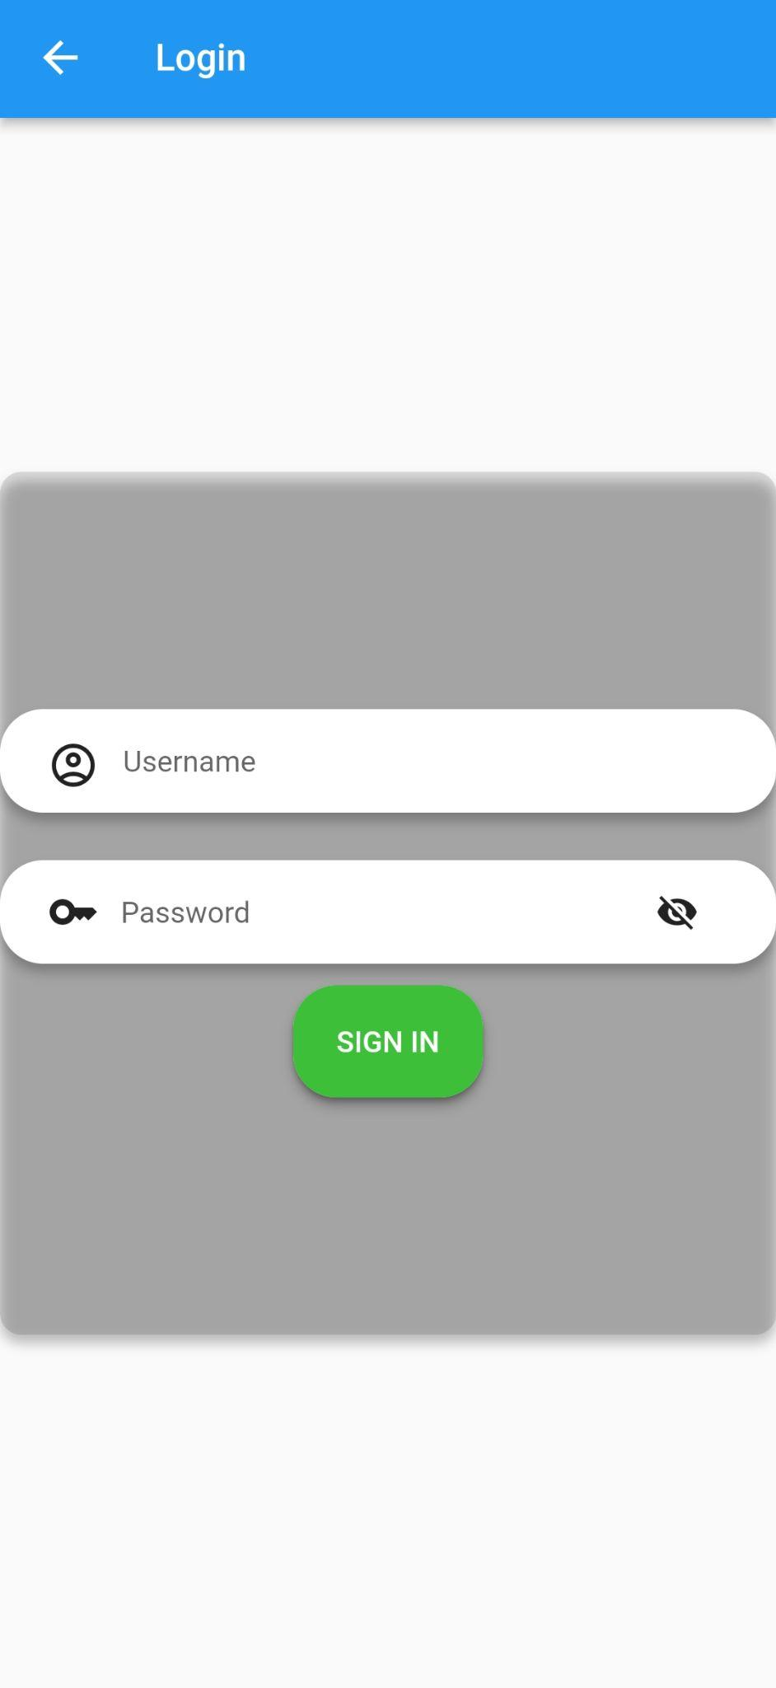

* Apabila username dan password tidak di isi maka akan tampil snackbar

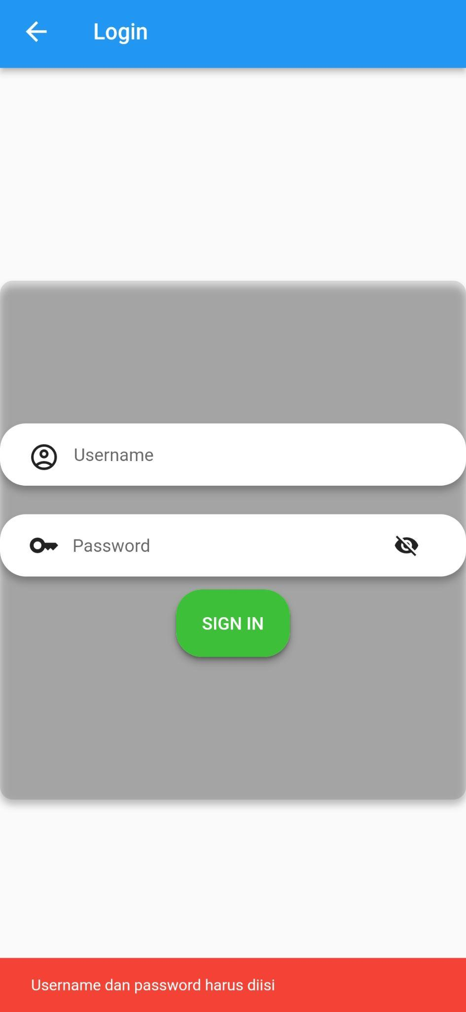

* Ketika login berhasil maka akan muncul dialog, dan ketika di klik “Ok” maka akan berpindah ke halaman contacts

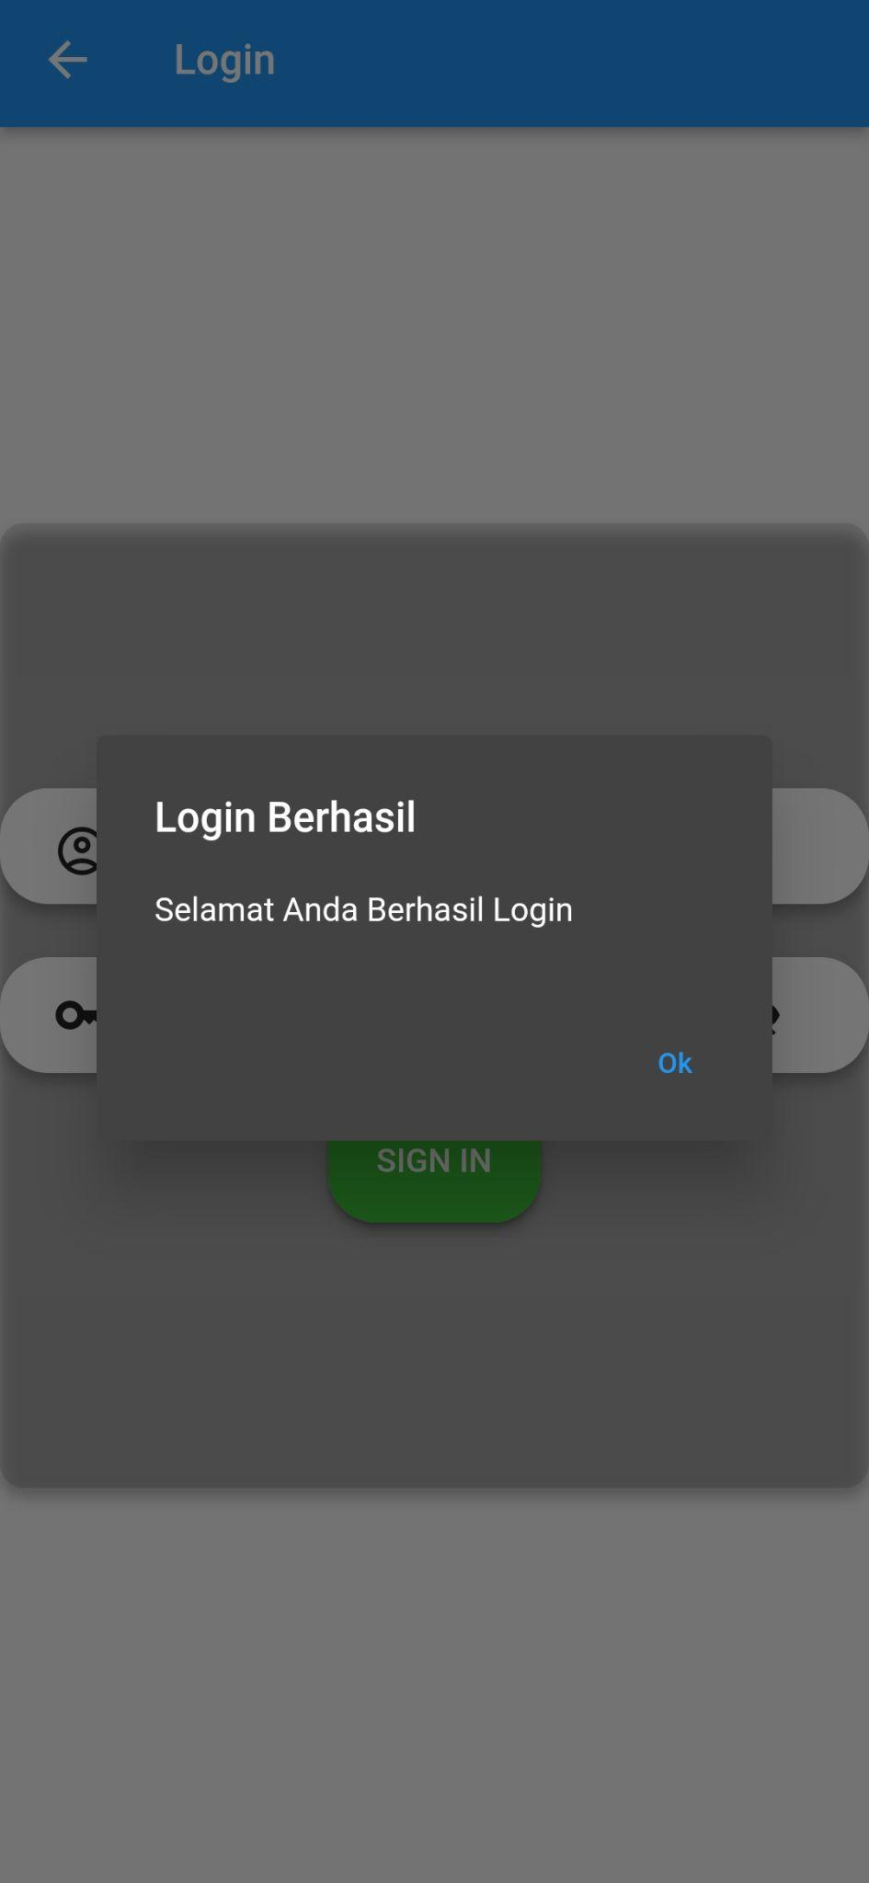

* Menampilkan username pada halaman contacts

Container(

alignment: Alignment.center,

padding: const EdgeInsets.only(top: 10),

child: Text(

"Halo, $username",

style: const TextStyle(

fontFamily: 'Roboto-Regular',

fontSize: 24,

color: Colors.black),

),

),

* Tampilan username pada halaman contacts

